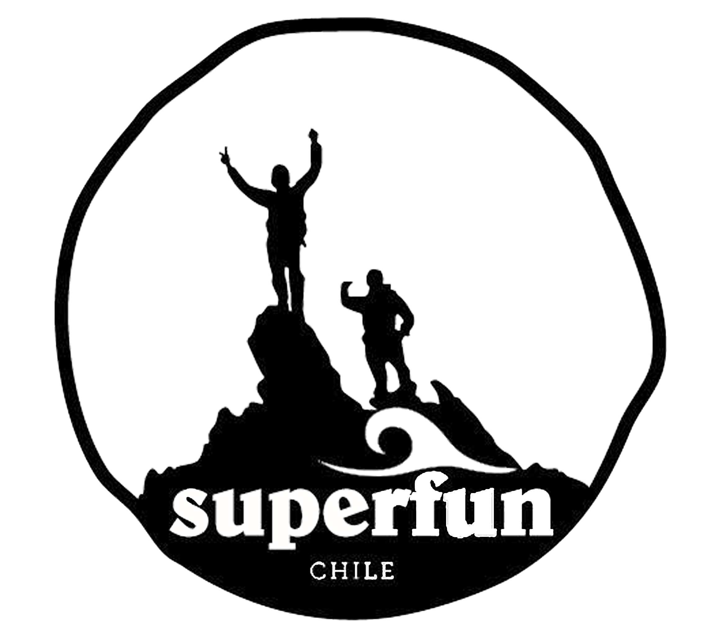
SAFETY PROTOCOLS WWW BY SUPERFUN

First, we practice and teach “risk prevention.” Students are taught there are 2 types of danger that they can avoid: Objective and Subjective. An objective danger is one we cannot control (such as bad weather, slippery rocks, strong currents, etc). A subjective danger is a risk we take when faced with objective danger; we can control it by monitoring our thoughts and actions so we avoid risk, and prevent any accident that might occur. If an accident does occur, we have the training and the tools needed to “first respond” and stabilize the victim’s condition.

—We have in our group 1 certified lifeguard and first responders: Emilio Garcia de la Huerta Sutil and Nicolás, Benjamin and Valentina Carvallo. Additionally: Emilio is certified in Wilderness First Aid, and Valentina Carvallo Pirola is certified as a first responder and in avalanche rescue by AIAIRE, Level 1.
Secondly, students are never alone unless they have been granted permission to be so. Students and staff will be carrying cell phones at all times.

Additionally, staff carries first aid kits so if there is an injury in the field they can stabilize the condition until EMS arrives.

We will use special boards called soft boards (of Soft Tops); they are long and soft boards that prevent accidents that might be associated with hardboard surfing. This is the most concrete way we have to mitigate the injury in case someone crashes, because they are made of a sponge and have rubber flexible fins, (hard fins are dangerous). We will wear special high quality wetsuits to prevent hypothermia. In addition to our own lifeguards, the Beach Punta de Lobos has 4 surf schools with many lifeguards at the beach at all times during the summer.

Emilio, our certified surf teacher, is also a lifeguard. In the theoretical part of the lesson, students will be taught the basic signals they will use to get help in case anything happens, and all of our safety procedures, including having a rescue board and a spinal board at the hotel 30 meters from the class (Superfun’s rescue plan is attached) . Students will be monitored closely, and will be given clear instructions and warnings about the hazards of surfing and of Punta de Lobos, the place and waves they are surfing. In Punta de Lobos there are waves for every skill level: beginner, intermediate and expert surfers. We will be teaching in the beginner area, where the waves are small and it is close to the shore.
24/7/365 on-call protocol

Our protocol at all times is risk prevention, as explained above. We will always be available to the students, and they will be informed about what to do in case an accident occurs. If that happens, we will apply the urban area protocol.

In case of emergency, staff will be lifeguards and first responders, and stabilize the victim’s condition until EMS arrives. Valentina Carvallo Pirola will attend the victim at the hospital, and contact parents and the school.

EVALUATION CRITERIA
Students will be given assignments on each activity, suddenly walking wild áreas we will ask them to write reflections they have. They will be asked to take notes about the species that we get to see, to take pictures of them, to shre their ideas in a circle, t oread loud voice some times… Their journals will be treated like Bruce Chatwin or John Muir diaries, that will be their main source for their reports we will donate to Fundacion Punta de Lobos to demonstrate the Project is highly valuable as an outdoor classroom. In a scale from 1 to 7 they will have; 2 points for their creativity on their reports (one in Pichilemu and one in Santiago), one for empathy, one for performance and one excellence.
Empathy will be understood by their self-leadership, if they show up on time with a positive, proactive attitude. That will be very important; their attitude towards others, and their attitude with the whole group and the environment.
Performance will be assumed as if you give your 50% you have one point and if you give your 100% you will have the entire point for performance.
Excellence will be understood as going beyond the program, to get to really experience new ways to camp, to feel like a true explorer, to be called to become one for life and hopefully one day work with us!

