Multisport Education Excursion – 2018
Exploring Colchagua Valley by Bike, Horse & Seakayak

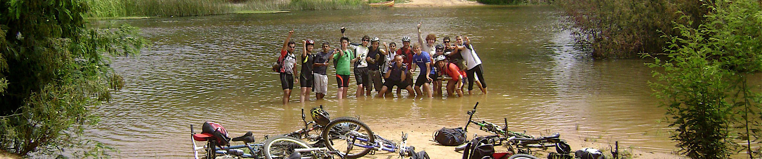

I. General Description
Multisport is a special educational program prepared for Nido students. It is a trip combining three different activities in one of Chile’s most traditional locations. But this trip is more than that, it is also a personal challenge, since every member of this adventure will have to face his/her own personal goals.
The trip entails gently pushing the comfort zone of our physical and mental abilities, organization skills, even our ability to work as a group.

With very clear educational goals, our group of students will travel through Colchagua Valley learning about traditions, history, flora, fauna today’s life.
Students will use bikes, kayaks and horses to see and discover interesting and beautiful corners of Colchagua from Santa Cruz all the way to the coast.
As leaders of this trip, we will put a especial emphasis on “LEAVE NO TRACE” concept, TEAM WORK and LEADERSHIP.

Group will meet at Nido School at 8:30am morning 5 of November for a trip direct to Santa Cruz where this adventure starts.
Group will return to Santiago the Morning of Saturday 10 November. ETA 11am.

Cost per person CL$ 395.000 (Min 8 Participants – Max 17 Participants)
Exploring Colchagua Valley is leads by professional guides (WFR certified). Guides will always be with students and assist them in every aspect of the trip.
A very especial stress is set on safety, not only during the activities but throught the entire trip.

Ground transportation from Santiago and back to Santiago is provided in a van plus 4x4 vehicle for the transportation and students, guides and all the equipment for this adventure.

Grado Sur Expediciones Ltda
+56 9 4407 0503
Pablo@gradosur.cl / info@gradosur.cl
www.gradosur.cl / www.aventuracolchagua.cl

