Multisport Education Excursion
Exploring Colchagua Valley by Bike, Horse & Seakayak
2018
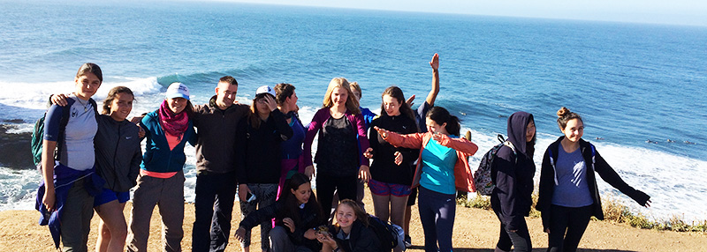

I. General Description
Multisport is a special educational program prepared for Nido students. It is a trip combining three different activities in one of Chile’s most traditional locations. But this trip is more than that, it is also a personal challenge, since every member of this adventure will have to face his/her own personal goals. We know that each student will have different levels of experience in the three disciplines: biking, horseback riding and kayaking. So one of the activities will be easier than the others and one in particular more of a personal goal. But they are also meant to be fun, and they will be.
The trip entails gently pushing the comfort zone of our physical and mental abilities, organization skills, even our ability to work as a group, and encourage the idea of forgetting about ourselves for a minute and helping others.
This trip will help students to learn that the biggest challenge is usually in our heads and the way we approach our lives.

II. Activities
a. On bikes group will traverse across the valley from the city of Santa Cruz to the small town of Cahuil, by the Pacific Ocean.
b. Horseback riding in the valleys around Lolol.
c. Sea Kayaking in the Bird Sanctuary of Lake Cahuil.

III. Educational Objective
a. Group will learn how to handle a bike for a long trip.
b. Group will be instructed on horses and practice before going on a 3-hour ride.
c. Group will receive instructions on kayaks and will practice paddling and safety drills before a 3-hour journey into the world of birds in the Bird Sanctuary of Cahuil.
d. Group will observe and learn about more than 20 different species of birds both migratory and local and about their habitat.
e. Group will learn about camping, planning and cooking meals. Especial emphasis on “LEAVE NO TRACE” concepts.
f. Group will focus on TEAM WORK and LEADERSHIP.

Cost per person CL$ 395.000 (Min 8 Participants – Max 17 Participants)

IV. What this Educational Excursion Includes
Grado Sur Expediciones provides you with transport and MOST of the gear needed all through the trip.
- We organize lodging at the places we are going to visit. We might stay in nice cabins one day, in a beautiful campground the next, or share one single giant room in our sleeping bags at a rural school.
- Together with students we plan and prepare most meals. We have a permanent cook with us, but students will be taking turns to help and contribute to meal times every day.
- As this trip involves three disciplines, we do not expect people to own bikes, kayaks or horses. We don’t even expect people to own gear for any of the three sports. So we provide:
- Bikes and helmets
- Kayaks, life vests, paddles and spray skirts (helmets are not needed)
- Horses, saddles and helmets
- Grado Sur Expediciones has a group of professional guides who will help students through the entire trip, motivate them and assist them in anything they need.
- Grado Sur Expediciones will also supervise activities from a safety point of view. We do have Risk Assessments for all activities and a strong safety protocol that we all follow.

V. Day-By-Day Itinerary
DAY 1 - Monday November 5: Drive from Santiago to Santa Cruz.
Group meets at NIDO School at 8:30am for an early drive to Santa Cruz. We arrive in the city at around 11am. Enough time to walk around the city, visit the interesting Colchagua Museum and have lunch before our biking starts.
We prepare bikes to explore Santa Cruz, the plantations, vineyards and the local community of Isla de Yaquil.
One of the main goal of our day 1 ride is to acclimatize to biking and to kearn about the essence of Colchagua Valley: The colonial influence in constructions, the influence of country like life in economical activities, and other important aspects that make Colchagua important in the forging of Chile as a country.
Late in the afternoon we drive to our camp-ground just 20 minutes away. Here we set up our tents and enjoy a nice dinner prepared by our cook. Students help.
Night at Camp Ground.

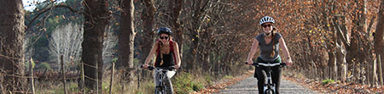

Day 2 – Tuesday November 6:
Ride Around Old Traditional Town: Lolol - Visit Local School - Community Service - Soccer Game.
Breakfast at 8:30am at our campground.
Then, we pack and load everything and prepare our bikes for an interesting ride across another beautiful valley. We visit the small and traditional town of Lolol where we will have lunch at a local restaurant.
After that we ride just few kilometers more and visit the Local Rural School at Nilahue, where we will spend time with local students and do a little fence repair work (repair and paint). We will have time to share with these students as well.
Before the day is over, we eat our dinner and gather to discuss the day’s experience.
We stay in the school. We use our sleeping gear and use the bathroom and showers.

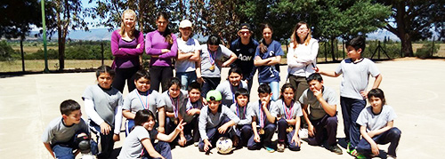

Day 3 – Wednesday November 7:
Day at the Horse Riding Center in Nilahue.
Breakfast at 8:30am.
Not far away, Grado Sur Expediciones has a small “ranch” with horses. We will spend all day there learning about these noble and beautiful animals, about riding gear and how to saddle a horse. Then, we will enter the local mountains and forests for a 4 hour ride. We will be stopping at various locations for pictures, rest and safety checks on our riding gear. We pack our gear and start our ride to reach our next destination, the small country town of Paredones. The Group cycles 30 kms along rolling hills within the coastal mountain range. The support van will follow us along the way. The ride takes about 3 hours. It is easy terrain but the ups and downs make it physically demanding.
We do it at a regular speed, and we will take breaks on the way to hydrate and rest.
Lunch on the way.
After lunch we ride the last portion of the route and arrive at what will be our next camp-ground. The Group set up tents and organizes the camp-ground.
Free time to relax.
Dinner prepared by Gradosur - Cookout.

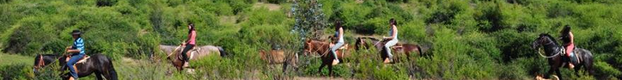

Day 4 – Thursday November 8:
Crossing over the coastal mountain road to the Bird Sanctuary at Laguna Cahuil.
Breakfast at 9am.
We get ready for a great day and the last day of biking, before we arrive at our destination: the Ocean and Laguna Cahuil, Pichilemu.
This is a great ride, but it is probably the hardest. Lots of up and down hills across beautiful coastal mountains with great views of the coast, local farms and forest.
Lunch by the river at the area called Los Cobres.
We ride for another 7 kilometers to our last camp-ground.
Free time to relax at the camp-ground close to the beach.
Dinner prepared by Gradosur - Cookout.

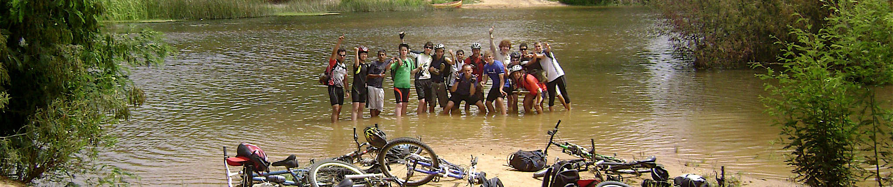

Day 5 – Friday November 9:
Introduction to Kayaking: Paddling across Laguna Cahuil and the Bird Sanctuary.
Farewell Dinner.
Breakfast at 8:30am.
Time to roll up tents and start packing. We are not leaving yet, but for our last night we will be staying at local cabins and nice comfortable beds.
Early morning we get ready for our last activity of the trip: Introduction to kayaking. This involves a safety talk, safety drills, getting familiar with kayak gear, and learning the basics of paddling.
Lunch by the lake:
Right after lunch the Group starts the kayak expedition through the Bird Sanctuary.

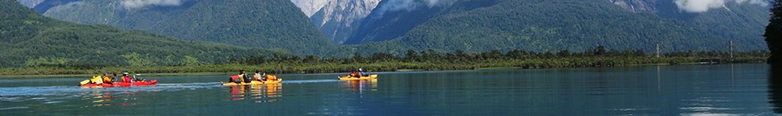

- Farewell Dinner prepared by the Group and Grado Sur. Night at local comfortable cabins.

Day 6 – Saturday November 10:
Wrap-up activity - Pack for our trip back home.
Breakfast at 9:30am. Time to pack and load our bikes and gear and start our trip back to Santiago.
ETA in Santiago 2pm.
(NOTE: OPTIONAL RETURN TO SANTIAGO Friday November 9 in the Afternoon)

IV. IMPORTANT
a. The staff includes two guides certified in WFR: Pablo González Díaz and Diane Gutierrez.
b. During this trip, we will always be within 90 minutes’ drive of medical assistance. However, we travel with an emergency first aid kit, extra support-vehicle and other necessary items to be used in case of emergency.
c. Grado Sur has VHF radios fitted to all its vehicles, plus a hand-held VHF radio per guide. Besides, every member of staff carries a mobile phone. All this guarantees communication throughout the entire trip.

V. TRAVELING DYNAMIC OF THE EXPEDITION
Meeting before the Trip
In most expeditions of this nature, we consider it very important that participants and Grado Sur Expediciones meet at least once before departure:
To talk about details of the trip
To talk about training before the trip
To discuss options for Community Service
To talk about the PACKING List and bag-size.
To discuss the personal equipment needed for Biking, Kayaking or Horseback Riding.

Grado Sur Professional Team
- Pablo Gonzalez Díaz – Professional Guide + 56 9 4407 0503
- Magda Ruiz de Prada – Professional guide + 56 9 8301 7847
- Diane Gutierrez – Professional Guide and cook + 56 9 9324 9067
- Igor Pecovnick – Professional Guide and driver + 56 9 9936 8991
- Marco Ibañez - Professional driver and Logistics + 56 9 9281 4548
- Grado Sur Expediciones + 56 9 9380 5359

Service Provided By Grado Sur
- All lodging: 3 nights at campgrounds - 1 night in cabins in Cahuil.
- All meals either cooked by students and Grado Sur Staff, and two meals at restaurants)

Gear Provided by Grado Sur Expediciones Needed for this Expedition
- A Mercedes Benz Sprinter mini-bus for all ground transportation. It has 15 seats plus driver. All seats recline and have "seat-belts". Also, every seat is insured.
- A trailer especially designed to transport equipment: bikes, camping equipment, food and personal gear.
- 4X4 support vehicle.
- An extra Trailer to transport boats and kayaks.
- Bikes and helmets
- Kayaks, all paddling gear
- Camping equipment such as: cups, plates, cutlery, tables and stools.
- Two-way long range VHF radios for guides and for key people in the group.
- Horse saddles and riding helmets
- Experienced Horse riding guides

Gear Each Expedition Member Needs to Bring - Remember to pack as light as possible
- We suggest expedition members bring:
- Padded Riding-Pants key for LONG RIDES.
- Their own biking gloves.
- Appropriate riding shoes and wind-proof jacket
- Sleeping bags & mattress (Grado Sur will provide Tents – Two person Igloo)
- Small backpack to carry personal items while cycling such as snacks and extra water.
- Towel and personal toiletries
- Hat, sun block and sunglasses
- Swimming suit and one non-cotton long-sleeve t-shirt.
- Flash light (Headlamp suggested)
- Warm clothes for after riding and evening activities.
- Spare shoes or sandals (Heavy walking shoes are not necessary in this trip)
- Spending money. This is simply for personal items.

DON'T BRING
- Computers or any big electrical item that might get damaged in the trip.

