Nido de Aguila - Week Without Walls
Trek Tagua Tagua & Kayak North Patagonia

Trek in Northern Patagonia and Kayak on the Reloncaví fjord
8 days/ 7 nights

During those 8 days, we invite you to discover, along with our professional guides team, the best of the Lake District in the Patagonian Andes of Chile. We begin with local hikes on the Osorno volcano. Then we will trade our walking boots for kayaking paddle to navigate the Reloncavi fjord for a 2-day expedition before entering the deep old native forest in the TaguaTagua Park. Here we will walk in the forest of Alerce trees, Ulmo, and Lenca, some more than 2.500 years old. We will cross crystal clear rivers and admire great waterfalls. Get submerged in the landscapes of this beautiful Region.
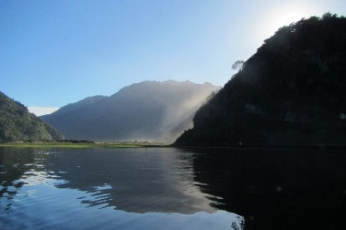
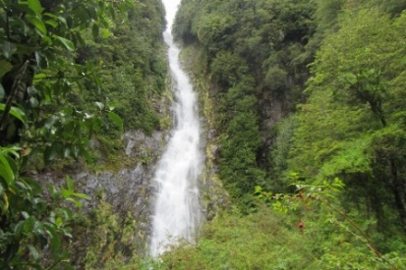
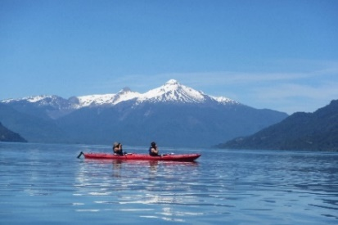

ITINERARY

SATURDAY, Nov 03rd: SANTIAGO / PUERTO VARAS
Flight from Santiago to Puerto Montt and land transfer to Puerto Varas. Upon arrival at your camping ground, you will get a briefing of your next days in the region and prepare the equipment for the trip with your guide’s assistance. Have dinner with your guides and share your expectations around a camp fire.

*Educational Component: Reviewing the itinerary, you will have a map that will keep you aware of where we are going and the geography that we will discover on the following days.

SUNDAY, Nov 04th: VOLCAN OSORNO, PASO DESOLACION TRAIL
Our hike begins at 800 meters above sea level, on the base of the Osorno volcano. We begin with a light rise of 400m while circumventing the volcano and head down towards lake Todos Los Santos. During our 12-km walk, we will have spectacular sights of the Tronador and Puntiagudo volcanoes, the snow-covered summits of the Andes, and the emerald waters of the lake. The name of this path ¨Paso Desolacion¨ or
“Desolation Path” refers to the low vegetation of lichens and shrubs (due mainly to altitude) that allow for a 360-degree panoramic view for most of the walk. We will camp on the side of the Lake Todos Los Santos.

*Educational Component: Student will learn about Volcanic eruptions of the Calbuco (2015) and Osorno (1834) and the impact on the population of Ensenada.

MONDAY, Nov 05th: KAYAK FJORD RELONCAVÍ to COCHAMO
Our first day of kayaking will be a navigation on the fjord between the villages of Ralún and Cochamo for 17 km. On our way, we will be able to observe the Yates volcano and snow-covered mountains. It is likely that we will see dolphins and sea lions, main residents of the fjord. During lunch time, we will stop at a farm where the owners, a friendly local family, will share the magic of their sustainable lifestyle. From our kayaks, we will visit the village-relay of Cochamo.

*Educational Component: Students will learn about the fundamentals sea kayaking skills: Parts of the kayak, the best way to paddle efficiently. Learning about the economy of the local relying on the salmon and mussel industries, but also their self-sufficiency and trades in the neighborhood.

TUESDAY, Nov 06th: KAYAK RIO COCHAMO
On Cochamo’s river, a calm and pristine river coming from the Andes snow melting, we will increase our skills and kayaking techniques during the morning. In the afternoon, we will continue our navigation toward Puelo village. A small transfer of 25 km, will bring us to a cabin where we will sleep.

*Educational Component: Learning a little more about sea kayaking skills: procedure in case of a capsizing and how to benefit the water currents during navigations.

WEDNESDAY, Nov 07th: VALLEY PUELO - Parque TAGUA TAGUA
In the morning, we will take a transfer to reach emerald waters of lake Tagua-Tagua. With a 20-min motor boat ride, we will reach the entrance of the private park: a gorgeous 70-meter high waterfall. A walk of 8 km will bring us to a mountains refuge where we will sleep in dorms.

*Educational Component: Talking about the forestry during the time of the first settlers and the way of living until the arrival of the road access and public ferryboat services.

THURSDAY, Nov 08th: Parque TAGUA TAGUA exploration
We will keep exploring the valley, crossing waterfalls, and following a trail where trees become bigger and bigger (until 3000 years old specimens), we will reach the second refuge situated on the side of a glacier lagoon at lunch time. Then walk down to stay in the same refuge.

*Educational Component: Talking about the importance of our native rain forest and the new protections on Alerces, Ulmos and Araucarias trees.

FRIDAY, Nov 09th Parque TAGUA TAGUA -PUELO
We will walk down the valley, getting back to lake Tagua-Tagua where a driver will be waiting for us to return to the cabins in Puelo.

*Educational Component: Learning about the geological formation of the region due to glacier path and tectonic movements.

SATURDAY, Nov 10th: TRF PUELO to PUERTO MONTT Apt.
After breakfast, we will drive back to Puerto Montt Airport to catch your flight to Santiago.

*Educational Component: Debriefing of their experiences, what they have learn and what they will remember from that trip.

PRICE per student: $900.000CLP

DETAILS

Trekking Total Distance: 53 Km
Sea kayak Total Distance: 30 km
Duration: 8 Days / 7 Nights
Night in Hostel, Cabins and Refuge: 4 Nights
Nights camping: 3 Nights
Level of difficulty: Moderate 4 to 6 hours of daily physical activity
Pack weight: 5k/ 11lb (day pack)
Luggage capacity: 70 liter max.+ Daypack
Location: Northern Patagonia, Lake District, and Puelo Valley
Meeting point: Puerto Montt airport
End of the trip: Puerto Montt airport
Departure: Saturday, November 03th
Group size: Minimum 4 students, Maximum 11 students.

CANCELLATION POLICY:
For cancellations, the total amount of the reservation is refunded except for the value of the plane ticket if it has already been purchased when it is made 20 days before the starting date of the trip.
Between 20 days and 7 days before the start date of the trip, 60% of the total value of the trip is refunded.
After that date, there is no refund.

INCLUDES:
Air tickets, emission cost and airport taxes From Santiago to Puerto Montt round trip.
All transport (land and boats)
All meals through the 8 days of activities (breakfast, lunch, dinner, and snacks)
All Lodging fees (3 x camping, 2 x refuge, 2 x Cabins)
Camping equipment: Tents for three people, kitchen equipment, and tarp.
Kayaking equipment: Sea kayak wilderness system with rudder, life jacket, spray skirt, paddle, neoprene wetsuit and booties, all safety equipment and 1 dry bag x 20L /pers.
Professional First aid kit, VHF radio, maps, repair kit and satellite phone.
Bilingual guides, with Wilderness First Response accreditation and many years of experiences in long expeditions in remote areas.
Guide rate: 1 Guide per 6 participants.
Park entrances and fees

NOT INCLUDED:
Personal equipment for camping such as:
Sleeping bag (0° C to -5°C)
Sleeping mattress
Head light or hand light
Warm clothing
Waterproof jacket

GUIDES:
Alejandra Freunde:
Chilean naturalist guide with 13 years of experience.
Advanced knowledge in botany, geology, fauna and flora, ornithology and magnifying glass tourism (lichens, mushrooms and vegetable cover observation) in Chile.
Fluent in Spanish, French and English. Wilderness First Responder- Renovelled in 2017
Sea Kayaking 2 days’ course- Safety and Rescues 2015

Alex Giroux:
Franco-Canadian, historian teacher and international guide for the last 8 years
Speaks French, English and Spanish fluently.
Wilderness First Responder- Renovelled in 2017
Sea kayaking 2 days course- Safety and Rescues 2016

TRANSPORTATION INFORMATION:
Flight: From Santiago to Puerto Montt airport
Land transport: By a mini-bus
Marine transport with sea kayak- Single and double kayaks Wilderness System with a rudder system. All safety gear will be provide: life jacket, spray skirt, neoprene botties, rope, pump, paddle float, etc.

HOTELS AND CAMPING INFORMATION:
Nov 03:
Camping Fundo La Poza Alta SN
Colonia Tres Puentes, Puerto Varas
Contacto Jass Puerto Varas +56 9 65906458

Nov 04:
Camping Esmeralda,
Petrohue, Comuna de Puerto Varas
Contacto: Señora Rosa +56 9 98392589

Nov 05:
Camping Señora Laura
Cochamó
Contacto: Señora Laura +56 998329054
O Camping Campo Aventura- Riverside Cochamo
Cochamo km5
Contacto: Mike +56 9 92894318

Nov 06:
Cabañas Puelo Siempre Verde
Camino Internacional rio Puelo SN, Comuna de Cochamo
Contacto: Pablo Zuñiga + 56 9 76687308

Nov 07 y Nov 08:
Refugio Alerce
Parque Tagua Tagua
Valle Puelo- Comuna de Cochamo
Región de Los Lagos +56 65 2234892

Nov 09:
Cabañas Puelo Siempre Verde
Camino Internacional rio Puelo SN, Comuna de Cochamo
Contacto: Pablo Zuñiga + 56 9 76687308

