Moby Dick Matanzas 2018 Course Line
English Version

The shocking reality of being the longest and narrowest country in the world creates the chance to explore our mountains and sea in matter of days. This new adventure of learning consists on different sports in different atmospheres and landscapes, is an incredible opportunity to learn with the best athletes and trainers from Chile.

Matanzas is a place that offers various adventures: here we can enjoy surfing lessons, amazing horseback rides, Stand up Paddle trips and yoga lessons.

Students will be divided into different groups, the idea is to enjoy expeditions in a personalized way. With this, it is expected to achieve greater impact on coaching reflections.
Camping information at:
https://www.facebook.com/Camping-Playa-de-Matanzas-1399788860078068/

1) SURF LESSONS.

1.1. Description: The class begins by given to the students a personal wetsuit and a suitable surfboard, according to their height and weight. As a result, teachers start the lesson explaining to them the proper use of the surf equipment assuring their safety.

After security instructions are held, teachers throw light upon several different tactics required by the surf initialization stage. Both standing and balance techniques are taught allowing student to locate their bodies over the surfboard at the right time, at the precise position. In this part of the lesson, coordination is crucial. Thus, there is a great focus on it.

Finally, once the students are familiar with the physical movements required, teachers proceed to explain the important environmental elements that should be considered in all kind of surf session. Before getting into the sea, students not only have to understand the role of the win in the wave-making process, but also they should comprehend how ocean tides could affect ocean conditions. Classes are organized in small groups, and each one of them is under the direction and guidance of a certified surf-rescue-expert teacher.

1.2. Place: The lesson will be held in Matanzas, a beach located very close to Camping. The place where the class is held has been strategically chosen. The beach is protected from strong waves and powerful tides, and it does not have rocks. In addition, to avoid any type of accident, lessons are taken place in shallow-depth sea waters.

1.3. Difficulty: Middle-low.

2) STAND UP PADDLE:

2.1. Description: Participants are moved to the town of La Boca, located approximately 10 km from Matanzas.
There this wonderful trip Starts. Here you can appreciate all the flora and fauna of the zone.
Instructors & lifeguards will guide this activity.
The expedition ends at the mouth of the rappel river, where a van will be waiting to transport the expedition back to the campsite.

2.2 Place: Rapel River, to the mouth.
River without difficulty, with current in favor towards the mouth.
It does not have fast or strong currents.

2.3 Difficulty: Middle-low

3) HORSEBACK RIDE:

3.1. Description: Another exciting activity organized for the students is horseback riding. The lesson is carry out by using the assistant of an expert local rider, who guides and helps teachers to maintain the order and the safety of the students throughout the entire ride. The horse path goes through out the dunes of Matanzas, until the hidden corners of Pupuya, a beach town very close to Matanzas. Along with horse riding lessons, students are introduced into the mythology of the place where very old legends are still strongly follow by the people who live around the area.

3.2. Place: The riding begins in Matanzas, and goes across its dunes until Pupuya Beach. For the same reason above, during the entire session there are both radio and cellular communication between the organizers attending the activity and the others who are at the camping waiting.

3.3. Difficulty: Middle-low.

4) YOGA:

4.1. Description: To start the day with energy and motivation, each morning students have a class of yoga led by a professional instructor. The purpose of this activity is to prepare their body and mind to successfully develop the activities of the day.

Yoga allows students to connect themselves in a process based on breathing and consciousness. Body, mind, spirit come together to create an awareness of the beautiful nature surrounding them. This connection is essential. Yoga involves a deep breath connection attached to a series of positions, which produce an internal heat that purifies the organs and muscles. As a result, Yoga introduce student to a mindfulness stage where their endocrine system is purified. The activity has been organized not only to encourage physical and mental health, but also to prevents the upcoming activities of the day from any possible injury.
4.2. Place: Matanzas Beach.

4.3. Difficulty: Low-Medium-High.

5) LUNCH PREPARATION:

5.1. Description:

Moby Dick Expeditions is focus not only in encouraging a healthy life style over the students, but also in developing the ability to work and enjoy among themselves as team groups. This section is based on the accomplishment of a daily-simple task: cooking. The students are responsible for choosing the ingredients, so that they can proceed to cook them under the supervision of an expert. Safety measures are applied, so each group has an advisor who provides direction and guidance over the young chefs.

5.2. Place: Camping Matanzas:

5.3. Difficulty: Low.

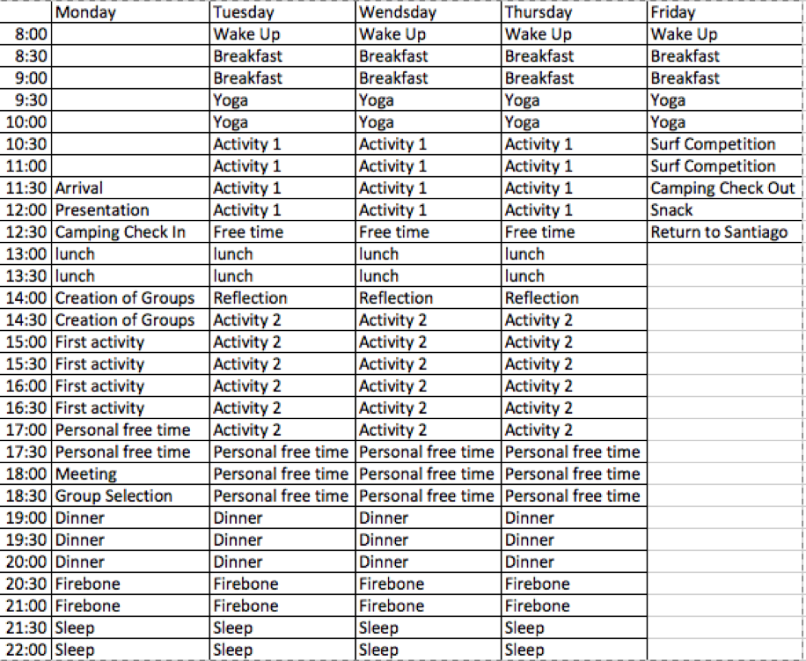

Camping information at:

https://www.facebook.com/Camping-Playa-de-Matanzas-1399788860078068/

Activities:
Horseback Riding
Yoga
Surf Lessons
Bike Riding
Lunch Preparation
Community Service

