Cochamó Valley Expedition
Week Without Walls 2018
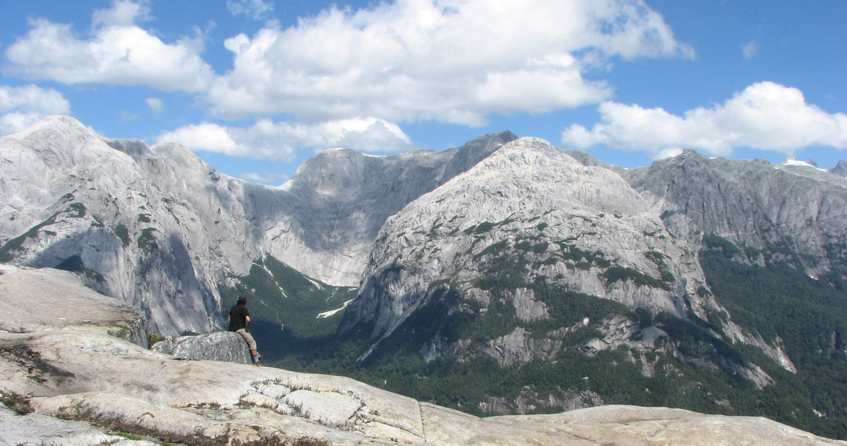
8 días / 7 noches

Travel Animal invites you to trek for a week to a unique place in Patagonia: Cochamó valley, also known as the Chilean Yosemite, is one of the most impressive places in Chile. With its gigantic granite walls, turquoise rivers and a dense native forest, it is the paradise for outdoor lovers.

Together with our team of guides and instructors we have designed an special adventure that allow students to take their outdoors skills to the next level as we travel and climb the most impressive places of this acclaimed valley.

Itinerary
DAY 01

Saturday, Nov 03: Santiago - Puerto Varas – Cochamó
Reception at El Tepual airport in Puerto Montt and transfer to Cochamó town, an small fishing village, located on the coast of the first fjord of Chilean Patagonia: Reloncaví estuary. In this town, we will set up our first camp and we will have an introductory class of the logistics and spirit of the expedition. We will also have time to tour the town and prepare the last details of the expedition.

Educational Component:
We will learn about key roles for the success of the expedition such as leadership, teamwork, selfcare and land navigation.

DAY 02

Sunday, Nov 04: Trekking to La Junta, Cochamó Valley
Early in the morning, after preparing breakfast and the rations for the day, we will move to the beginning of the Cochamó valley trail. In this place, we will prepare our gear and meet our local “arriero”, who will assist us with the load. We will also have a brief talk about hiking techniques and an introduction to Leave no Trace principles. Then we will divide in groups and we will begin a 9 kilometers hike through the forest until “La Junta”. Here we will spend the next 2 nights at the Cochamó refuge camping site.

In this place, we will have a class about camping and how set up a bombproofing tent. Later on, our friends from the camping will take us on a tour to show us the operation and management of the ecological facilities of the campsite. Then we will cook in groups and dinner next to a bonfire, while we talk about the highlights of the day.

Educational component:
The “ABC” of an expedition backpack, Leave No Trace principles and how to set up camp will be the main achievements of this day.
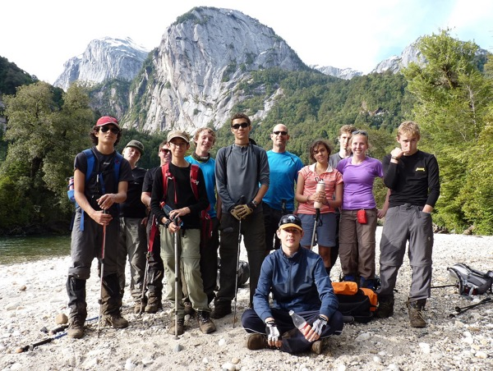
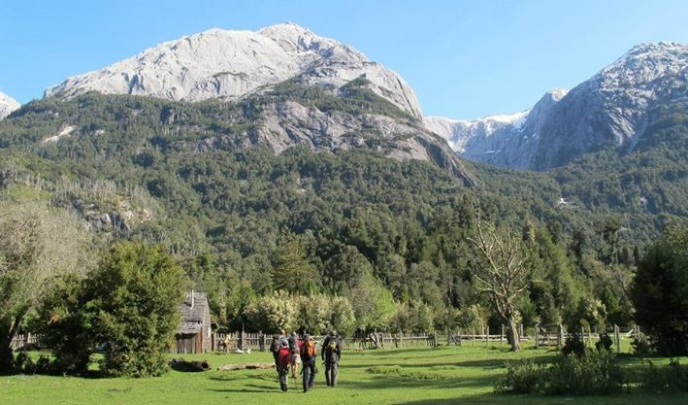

DAY 03

Monday, Nov 05: Mountaineering, rock climbing and safety in remote areas
This day will be fully dedicated to instructing techniques and developing skills related to mountaineering, climbing and safety in remote areas. This will allow us to level skills for the following challenges of our expedition.
These classes will be taught by our guides / instructors in epic places of the valley, such “toboganes de La Junta”, “Pared Seca” and Cochamó river.

Educational component:
During the day we will learn about safety in remote areas (correct use of harnesses and helmet), security knots, rock climbing basics and river crossing.

DAY 04

Tuesday, Nov 06: Trekking to “El Arco” camp
Early in the morning we will take down camp and begin a trekking to one of the most stunning places of Cochamó valley: “El Arco”, an incredible rock formation in the middle of a waterfall surrounded by giant “Alerces” (native tree similar to American sequoia).
The trail has a total distance of approximately 8.5 kilometers, it goes almost always under the rainforest, crosses multiple rivers and streams and the last part is more demanding due to the slope. On the way, will be necessary to apply much of the knowledge acquired so far as safety, mapping, river crossing, risk management, responsibility and self-care.

Once in "El Arco" we will set up camp and our local “arriero” will cook a Patagonian style lamb, while telling us about the history of the valley having “mate” with a bonfire under the stars.

Educational component:
This hike will be a rich learning environment, as students will not only have to make their own decisions but also reinforce skills as leadership and teamwork.
In addition, the night will be the right time for cultural interaction and learning about the lifestyle of the inhabitants of Patagonia.

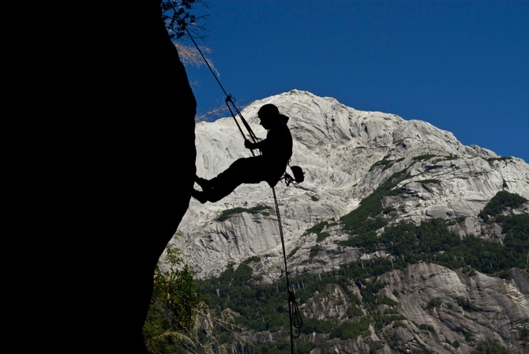
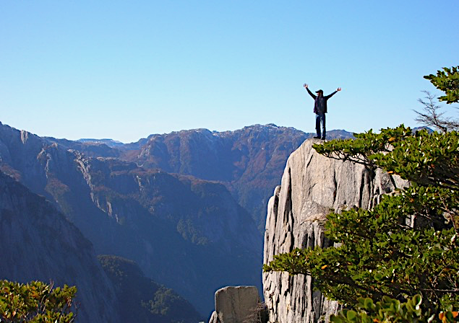

DAY 05

Wednesday, Nov 07: Trekking El Arco to La Junta
This morning, in this incredible place and as the first activity of the day we will have a fun environmental interpretation activity. Where students will go to a pristine forest of “Alerces” while learning about the ecology of the area. Then we will take down camp and beginning the hike back to “ La Junta”. The afternoon will be free to relax. Then we will cook in groups while we talk about the highlights of the day.

Educational component:
We will learn about flora and fauna and ecology in a pristine native forest.

DAY 06

Thursday, Nov 08: Climbing Arcoíris mountain
This day we will go to discover from above this beautiful valley surrounded by granite mountains. We will leave in the morning with the objective of ascending the “Arcoiris” mountain, one of the most impressive summits of the valley.
This day will be one of the toughest of the expedition, as we will ascend almost 1,000 meters in just 3.5 kilometers. We will also have to overcome 2 steps of fixed ropes secured by ropes, which will allow us to cross blocks of granite in the middle of the route.

On the way back we will have time to refresh in the river and then return to the camp for dinner by the fire.

Educational component:
This day students will have to test all the techniques and skills learned during the previous days. To achieve this summit, will be of vital importance that students assume a leading role in aspects such as self-care, leadership and safety.

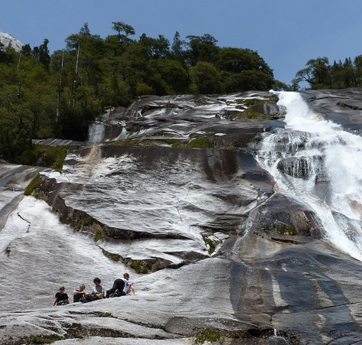
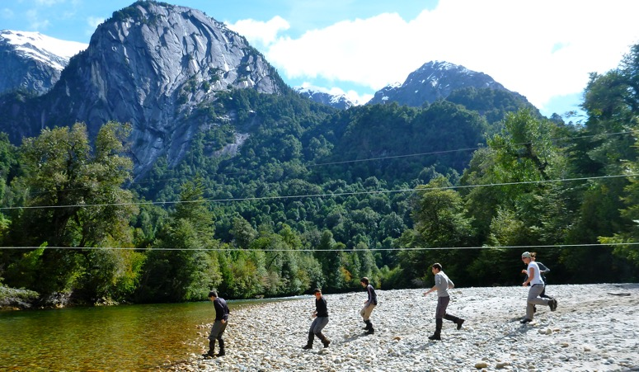

DAY 07

Friday, Nov 09: Hiking La Junta to Cochamó
We will dismantle camp, say goodbye to the staff of the camping that received us and we will start the walk back to the beginning of the trail.
Once down, we will prepare a special meal to celebrate the success of our expedition. We will also have time for a reflection that will allow us to verify the personal evolution of each of the students.

DAY 08

Saturday, Nov 10: Transfer to Puerto Montt Airport

From Cochamó our private transfer will take us to El Tepual airport in Puerto Montt.

End of services

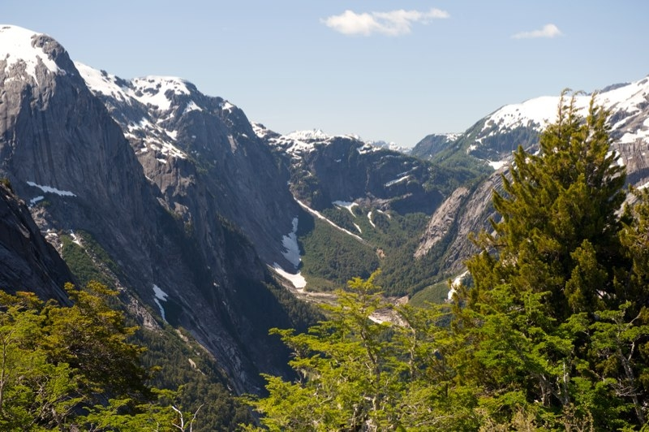

Details

- Duration: 8 days / 7 nights
- Nights in camping: 7 nights
- Difficulty: Moderate to difficult, 5 to 7 hrs of physical activity everyday
- Backpack weight: 10 a 15 kgrs, approx.
- Backpack size: 75+ liters
- Location: Valle de Cochamó
- Meeting place: Airport El Tepual Puerto Montt
- End of the trip: Airport El Tepual Puerto Montt
- Group size: Minimum: 7 students
Maximum: 28 students

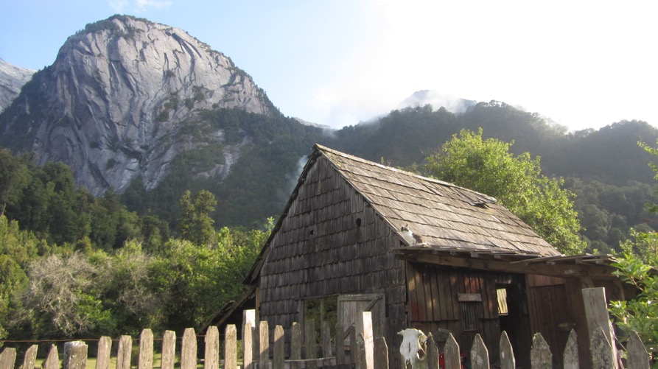

Revisa todos los detalles de este viaje en http://www.travelanimal.cl/weekwithoutwalls

