We recommend you pack everything into a soft travel bag or duffel bag and a day backpack (less than 25 lt.) which will be used to carry your essentials on a daily basis.

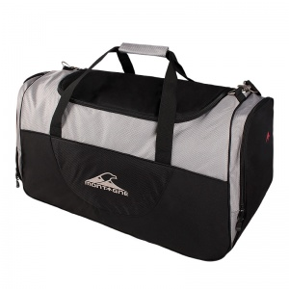 | or | 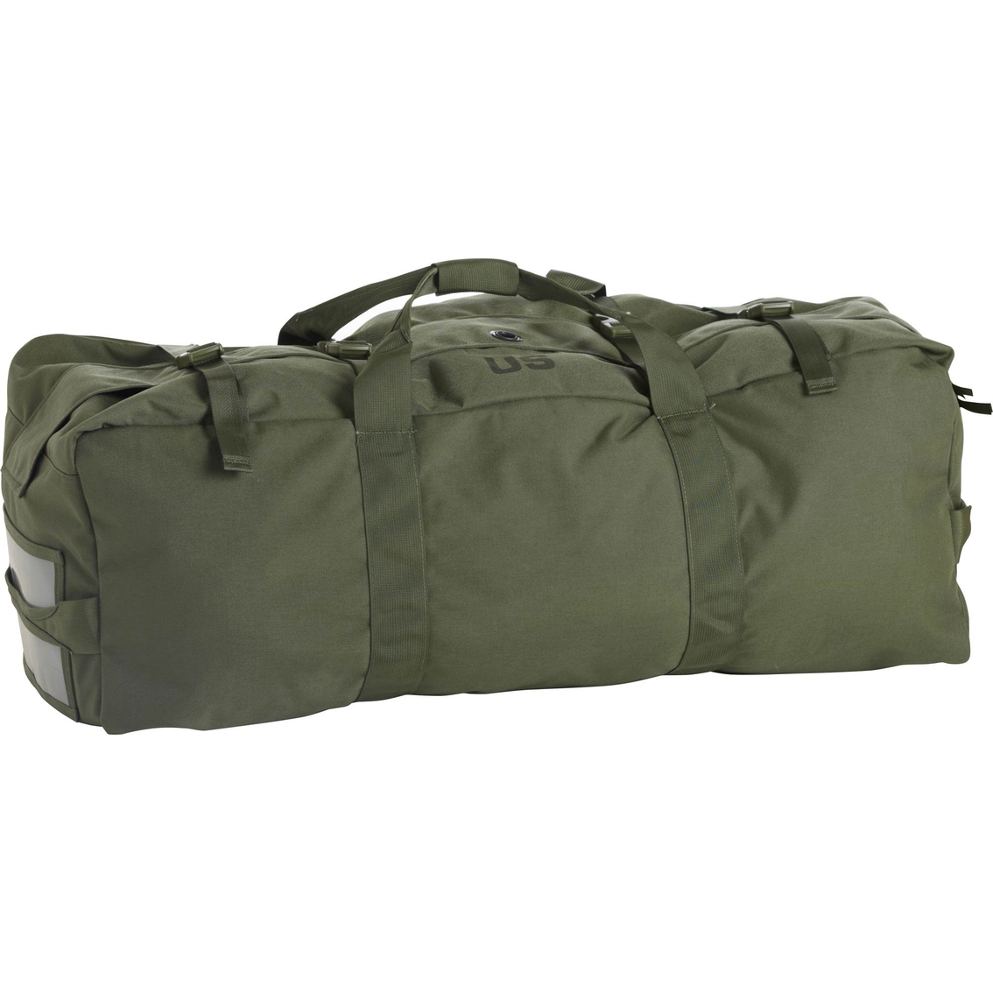 | + | 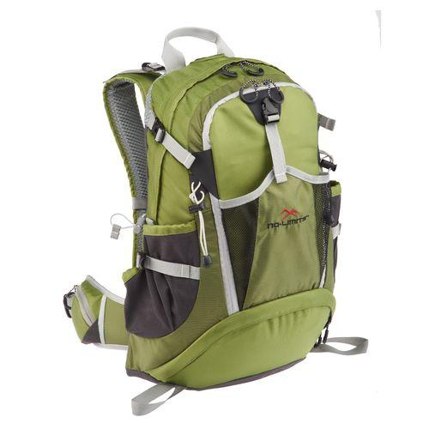

If you are missing some of the gear listed below, there are lots of options available that will help you save money. The Nido WWW Website lists several places where you can rent, borrow, or buy used or at discounted prices:
- Rentals
  - http://www.highmountain.cl/
  - http://www.rentandgo.cl/
- Community forums (buy used or at discount)
  - http://lilaslist.com/
  - NidoNeighbours google group (nidoneighbours@googlegroups.com): email group for Nido Families to see if folks have gear they are looking to sell or maybe even loan you.
- New store with excellent prices
  - Decathlon: https://www.decathlon.cl/
Address: Portal La Reina: Avenida Francisco Bilbao 8750, Las Condes

Let the teachers traveling with you (JuaneE and Javi) know what you are missing, and we’ll help you figure out what’s the best, most affordable way to get the gear you need.

CLOTHES
- Thermal base layers (2 top & 2 bottom)
- Warm accessories:
  - Hat
  - Fleece gloves
  - Buff
- Fleece (or other synthetic) jacket
- Waterproof, breathable parka (large enough to allow layering underneath)
- Hiking socks
- Swimwear
- Hiking pants
- Comfortable sleeping clothes (sweats or loose clothes)

GEAR
- Hiking shoes
- Extra pair of comfortable sneakers or shoes (for in-house use)
- Day Packs (approx. 25 lts.)
- Sleeping bag (+2ºC suggested)
- Sleeping mat + pillow (optional)
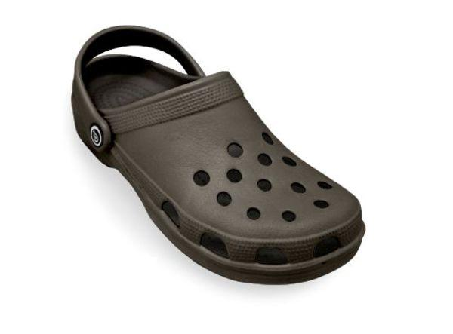
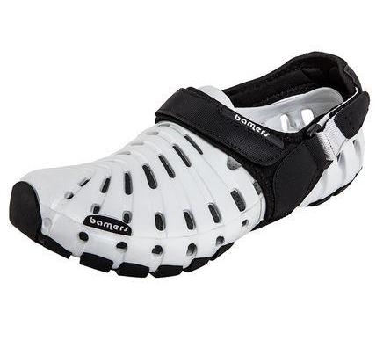
- Hiking Poles (suggested)
- Head lamp
- Sandals (River shoes or Croc-type shoe, not flip flops)
- Reusable water bottle

PERSONAL ITEMS
- Hygiene (toothbrush/toothpaste/hairbrush/shampoo/etc.)
- Personal medication (if needed)
- Quick-drying towel
- Underwear and Socks
- Sunblock / Sunglasses / Sun hat

OPTIONAL
- Binoculars
- Flashlight
- Running shoes/gear
- Snacks to share with the group: marshmallows, homemade cookies, chocolate, etc.
- Personal interest items/hobbies: book, photo camera, action-cam, sketchbook and pencils, etc.

