Week Without Walls Program

November, 2019

Golden Frog Scuba

Activities Proposal Information Packet

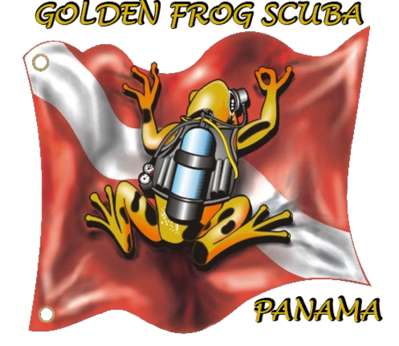

Golden Frog Scuba is proud to be selected to participate in this program and is excited to have the opportunity to teach the students of Nido de Aguilas the neccesary skills required to become a PADI certified Advanced Open Water SCUBA diver (which is a two day instruction/training course).
Our knowledgeable, patient dive instructors have over 40 years combined experience as Master Scuba Diver Trainers and safety is our top priority.

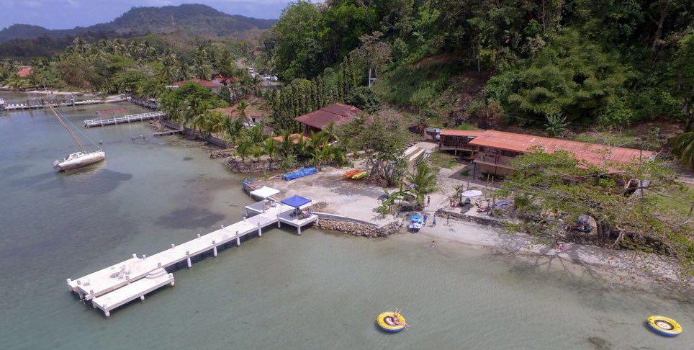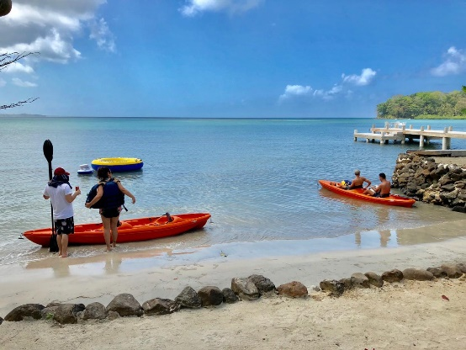

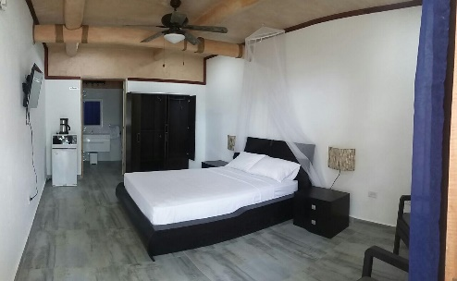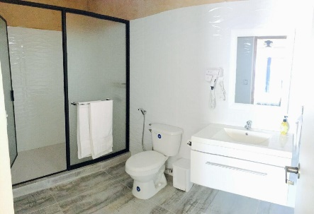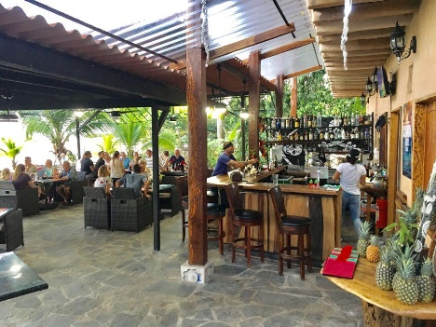

Learning to scuba dive requires both knowledge development – including facts, principles and concepts – and dive skills including techniques and methods. PADI Advanced Open Water Diver Online eLearning theory uses videos, audio, graphics and reading to help students learn, plus short quizzes that let them gauge their progress, and then offers a review of anything they happen to miss. Students will do this portion at their own pace, on their own time. To complete the online theory, it generally takes 6-8 hours in total. This portion should be completed prior to arrival of the event so that the student will have a better understanding of the instructional portion of certification. Students will develop the dive skills during actual dives with our PADI Instructors.

The first day of the dive instruction will teach students new skills. This will consist of learning to assemble additional diving gear (such as SMB with reel, lights, and emergency signal accessories), how to properly place the gear on the boat and learn how to communicate underwater with additional hand signals. Once at the dive site, reviewing and mastering the the bouyancy, navigation and safety skills. Students will learn new breathing techniques for buoyancy and the proper use of navigational aids. During the night dive, students will show proper use of light signals.
The second day of instruction will continue with skills and have the students working together with the buddy system used in diving. This will consist of learning how to dive at depth greater than 30 meters, reviewing the narcosis symptoms and decompression sickness. Students will learn how to properly use and engage the surface buoy and use of the reel. Students will practice sharing air during the safety stop while maintaining indicated depth.

Each day, the students will be briefed and debriefed about the days activity for clarification of information, allowing the opportunity for any questions or comments to be discussed.

During the 3 days of actual Diving Activities;

Students will learn new skills and to work together as a team utilizing the buddy system while diving historic sites in the waters of Portobelo National Park (such as remains from Sir Francis Drake’s armada (1561) and the island where Captain Morgan anchored during his attack on Portobelo), as well as obtaining environmental educations not only as to the colorful corals and marine life the ocean has to offer here, but the impacts that affect marine life due to predatory species such as the lionfish and debris that ends up in the ocean.

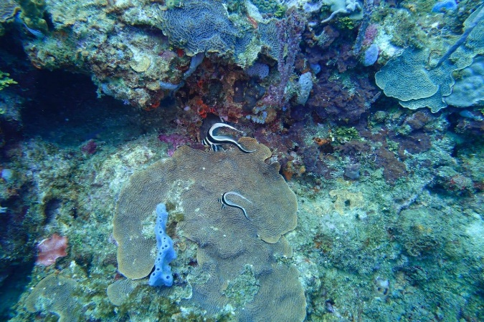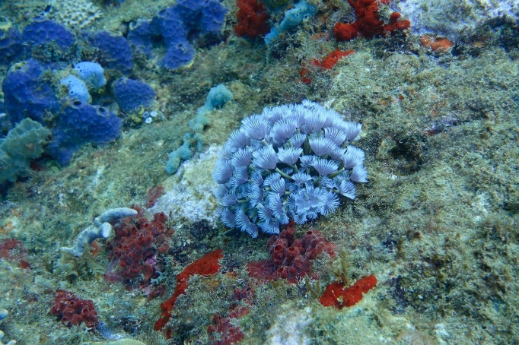

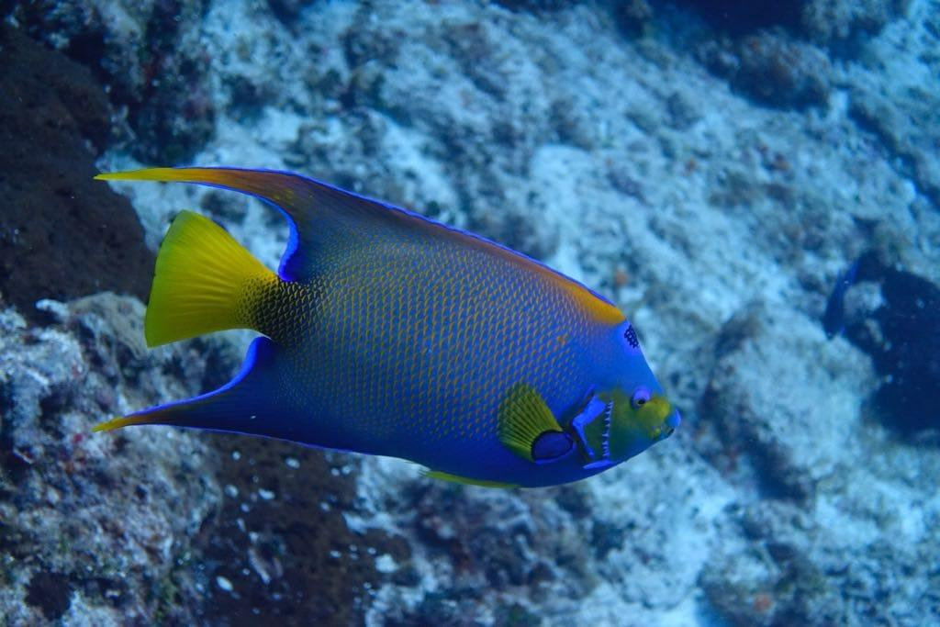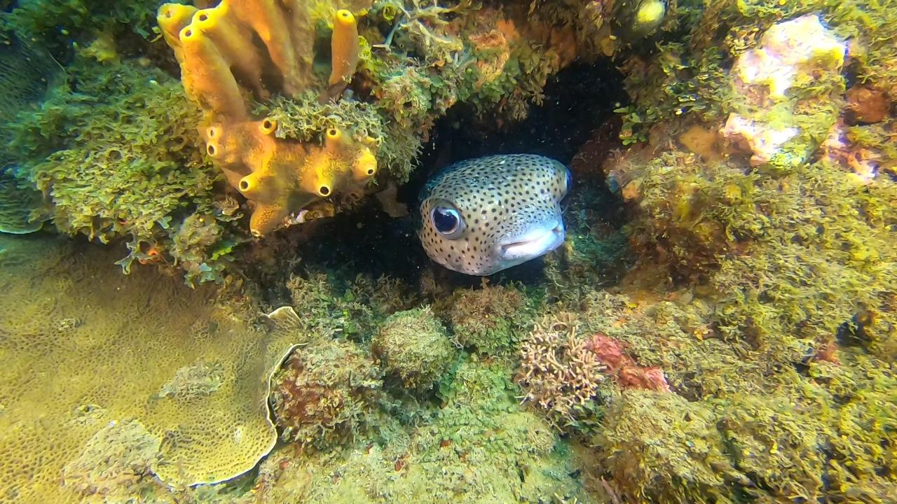

Lionfish are an invasive species that now represent one of the single biggest threats to biodiversity on the planet. They have a potential negative impact on native wildlife and habitat. Divers encourage the removal of lionfish in our waters to limit negative impacts to native marine life and ecosystems.
Students will be able to participate in lionfish hunting, learning how to safely catch them, then how to properly remove the venomous spines, clean and prepare them as a food source.

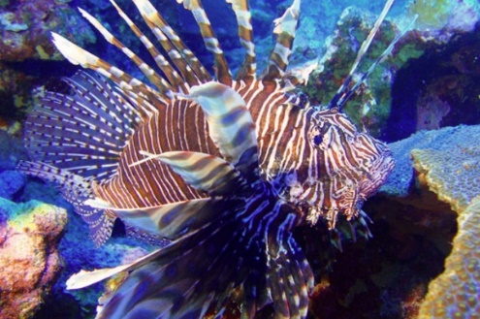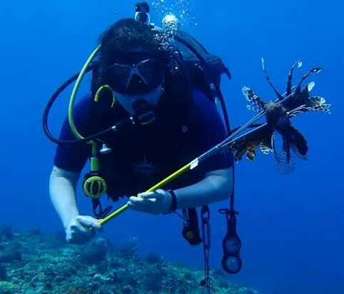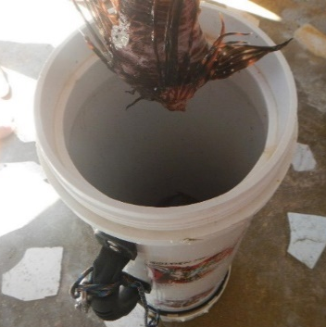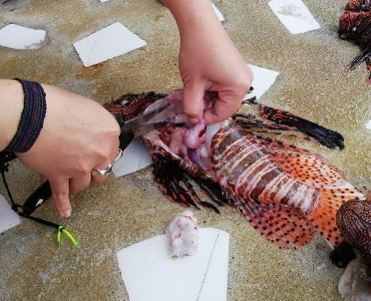

Students will also have the opportunity to visit the Panama Canal at the Agua Clara Locks, learning the history and importance of bringing two worlds together.

The visitor center offers a breathtaking panoramic view. On one side you will find the famous Gatun Lake,
where cargo ships or other vessels transit every day, while on the other side, but from a different perspective, you will be amased by the view of the expansión work.

There is a projection room where students can learn about the history and efforts of thousands of men and women that have marked the Canal’s first century.
There is also a gift shop where they can purchase memorabilia related to the Canal and its expansion.

