INTO THE WILD

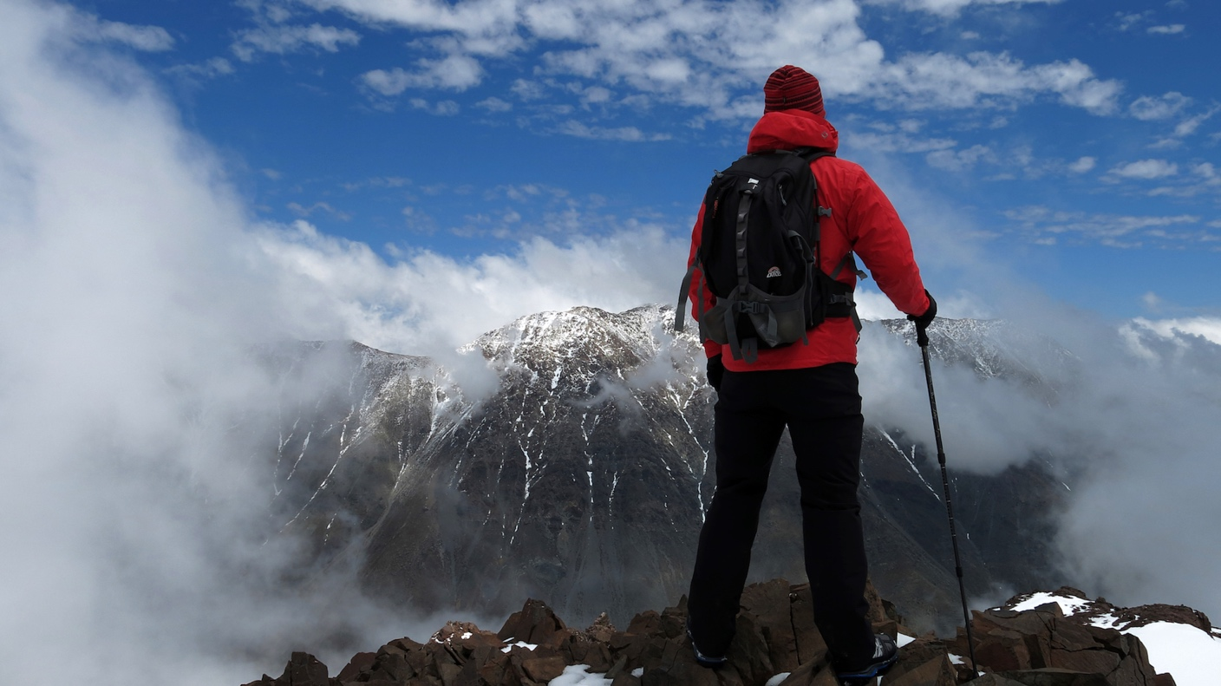

“The Mountain Experience”

Elqui Valley & Laguna El Cepo

* English Itinerary *

DAY 01: "WE START OUR ADVENTURE IN THE ELQUI VALLEY"
LA SERENA / EMBALSE PUCLARO / MONTE GRANDE / PISCO ELQUI

Monday, November 4

Reception of the group at La Florida Airport in La Serena, to begin our adventure towards the Elqui Valley. A specialized guide is who will accompany us and will be with us at every moment of this fantastic trip. We continue towards the Puclaro Reservoir, where the students, accompanied by their guide, will tour and delight with the majesty of the Elqui Mountains, with the sound of their Wind Harp, which with its 8 strings emits a sound that the wind blows. With their energy, they will be delighted with their metallic singing that sounds during several hours of the day by the wind that is permanent in the place. Its creator Mario Arenas Navarrete, in 2006 installed it next to the viewpoint that was built in the place. In Montegrande, we will visit the School House and the Mausoleum of our poet Gabriel Mistral. Later we will go to Pisco Elqui, to arrive at our accommodation in Refugio del Elqui (mountain place). We will have lunch in Vicuña and dinner will be included in the Refugio.
EDUCATIONAL COMPONENT: we will address the issues related to the trip that will take place in a group, the idea is to get away from the everyday and material things to achieve a journey with meaning, experiences and adventure.

SCHEDULES:
12:10 pm Reception at the Airport
12:30 pm Departure to the Elqui Valley
14:00 pm Lunch at Vicuña Social Club or other
16:30 pm Depart to Monte Grande
18:00 pm Arrival at the Refuge
20:30 pm Dinner at the Refuge

DAY 02: "LAGUNA EL CEPO"
PISCO ELQUI / COCHIGUAZ / LAGUNA EL CEPO

Tuesday, November 5

Breakfast included. We prepare to make one of the most beautiful excursions in the Elqui Valley, skirting hills, the river, following the trail of the muleteers in a boxed valley where in the early hours the sun embraces you. Laguna El Cepo or Laguna Verde is located at 2,790 meters. of height and 21 km away from Pisco Elqui. We will trek and find the flora and fauna of the sector. It is common to see on each route Cóndor, guanacos, goats, horses that walk around the place. We make a stop to rest and hydrate, and we will continue to enjoy in silence so that we can feel our heart rate and adrenalin racing in the mystique of the valley and its blue skies, to enjoy the mountains of different colors. When you reach the Laguna you will be breathless in front of such a beautiful show, seeing the mountains reflected in the mirror of water and enjoying the mystical place, enjoying the color of its mountains and the intense blue of its sky. At the instruction of the guide we will set up camp and prepare to share a dinner where we will learn to cook together, where each one will have a specific task to make this night a splendid night. We light a bonfire to enjoy a sea of ​​stars, rest and share what we have lived.
EDUCATIONAL COMPONENT: Extreme experience in high mountain (MSNM) learning to enjoy the pure nature and the care of the environment, we learned to NOT LEAVE A TRAIL.

SCHEDULES:

7:00 am Breakfast
8:00 am Depart to Cochiguaz Valley
9:15 am Trekking to Laguna El Cepo
12:30 pm Our first stop to regain strength
12:45 pm We keep walking
18:00 pm We arrived at the Cepo
18:30 pm. Set up camp
20:30 pm Dinner with the stars (bonfire and activity)

DAY 03: "TREKKING LAGUNA COLORADA"
COLORED LAGOON

Wednesday, November 6

Breakfast included, at the appointed time we prepare to go trekking to the Laguna Colorada, located 45 km from our camp to visit another wonder in the mountains, here we will experience the sunrise in all its fullness, enjoy the color of the sky and the mountains after the passing of the hours, we will leave very early from the camp and we will have the opportunity to observe the change that is provoked with the magic of this place. When arriving at the Laguna we can know all its surroundings that will always surprise us or follow the road to the summit 3700 mts. above the Valley. Later we return to the camp and visit the Rocks Garden located a few meters from the place, there we prepare ourselves so that together we prepare a delicious lunch, applying everything we have learned, lighting a fire, working as a team. At night we will cook around a stove where we will share our experience in the Mountain, we will do the Mountain activity, where the night will be full of emotions and legends, sharing lived adventures and lived anecdotes.

EDUCATIONAL COMPONENT: Life experience, team work, companionship development of creativity, autonomy, flexibility, initiative, commitment.

SCHEDULES:
05:30 am Ascent to Laguna Colorada
07:30 am Dawn
09:30 am Mountain Activity
14:30 am Return to the Camp
15:00 am Lunch at the Camp
17:30 pm Trekking to the Rocks Garden
20:00 pm Dinner

DAY 04: "PISCO ELQUI"

LAGUNA EL CEPO / OBSERVATORIO CHAKANA

Thursday, November 7

Breakfast included, we pack up our camp to return to the Refuge, appreciating the benefits of our sunrise and what nature gives us. We arrive at the Refuge, to regain strength around a pool with a surrounding of hills and clean skies that will take us to see a beautiful sunset with the color that gives us the different postcards that we can observe. At night, we will cook around a stove where we will share all the experience lived in the Mountain the previous nights. We will eat what we prepare ourselves, to later go to see the starry sky of the Valley in the Chakana Observatory.

EDUCATIONAL COMPONENT: Fellowship, acceptance of the defects and virtues.

SCHEDULES:

08:00 am Breakfast

08; 30 am Pack up camp

09:15 am Return to the Refuge

12:30 am. First stop to regain strength and continue to the Refuge

15:00 pm We keep going down (Box Lunch)

17:00 pm We continue towards the Refuge

18:30 pm Arrival at the Refuge

20:30 pm Closing and Dinner Activity

21:00 pm Chakana Observatory

DAY 05: "BACK TO HOME FULL OF ENERGY"
PISCO ELQUI / LA SERENA

Friday, November 8

Breakfast. Departure in the morning to return to our origin with a bag full of new experience, unforgettable experiences, new friends, memories that will allow us to look ahead in a different way, full of energy that gave us the fabulous Elqui Valley.
SCHEDULES:
9:00 am Breakfast
11:00 am Departure to La Serena
13:30 am Lunch at La Serena "Cabañas Quilacán"
16:00 pm Departure to the Airport to board the Flight

