Intensity: Active
Location : CHILE – Northern Patagonia

Program: Sea Kayaking Expedition and Rafting
course
Experience required: None

Do you want to develop your leadership, teamwork and decision-making skills? Look no further than our water program that will take you from the fjords of Pumalin park to the class III / IV rapids of the Petrohue river.
We’re thrilled to offer students valuable lessons in the great outdoors, as part of Nido de Aguilas’ Week Without Walls program.

In this expedition, you’ll trek along the fjords of freshly donated Pumalin National Park, get comfortable with sea paddling, and learn how to navigate waters according to the wind and tide conditions. At the same time you will understand better about river basins and currents in white water. You’ll learn about conservation vs the salmon farming industry and how to interact with Chilean national park system.
Ultimately, this trip will provide you with lifetime skills; you’ll gain confidence in reading maps, planning routes, using GPS devices, cooking fresh food, swimming in big volume rapids learn how to use a throw bag, purifying water, taking photographs, packing for camp, and how to trust your friends to get your back.

This is an opportunity for you to stretch outside your comfort zones. Without modern-day distractions, we’ll form strong team bonds and have time to appreciate Chile’s natural beauty. Groups of two to three students will alternate daily responsibilities, ranging from route planning to cooking, washing, and organizing camp. On the following pages you’ll find a day-by-day itinerary of what to expect on this kayaking adventure and rafting lessons.

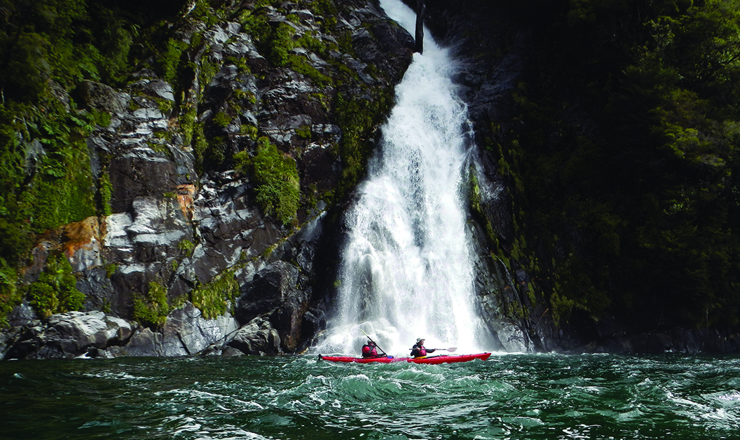
Fiordo Quintupeu

November 2nd : Meeting in Puerto Varas

We’ll pick up the group at Puerto Montt airport and go to our base in Ensenada to load the gear and kayaks. This is an important part of the excursion because we have to carry everything we need from our base. We’ll get to know everyone on the expedition and check our maps. Each student will receive a paddling kit, which he or she will use for the next few days. As we load our gear, we’ll also set up the inventory and menus. We’ll eat dinner and spend the night at a beautiful B&B in the foothills of the Calbuco volcano. It’s the perfect setting for planning the rest of our trip. D
Day achievements : how does the planning will influence the life on the trip, introduction to map reading, learn to pack for self support expedition, learn to drink and eat for long days out.

November 3rd : On our way to Patagonia

In the morning we’ll drive pass Puerto Montt and take our first ferry on the austral highway. We’ll reach the Comau fjord in the morning.
In Hornopiren we get the kayaks on our support boat and make it to Isla Llancahue for lunch.
After lunch it is time to go to our kayaking clinic and learn the basics of sea paddling and safety on the water. 2 to 3 hours paddling around the islands.
Back at the island it is time to get our kayaks packed for the following days and start cooking for tomorrow lunch.
Dinner is at the B&B on the island and we can relax a bit in the hot pools of thermal waters beside the B&B.
We go to bed early as tomorrow we need energy. B/L/D.
Day achievements : Students team up in pairs and have to work all together to be able to pack the kayaks and begin the expedition. Get to discover the community and learn basics of sea kayaking.
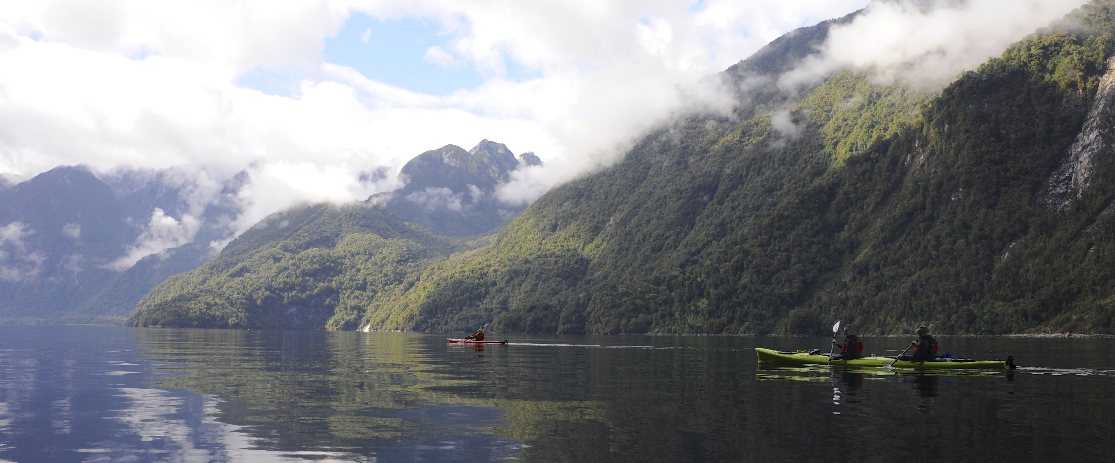

November 4th : Fjord crossing

We’ll be the first people to rise in the hotel, and will enjoy a good breakfast before returning to our kayaks. We’ll be on the water at around 7h30 for a slightly more challenging day.

According to the tides, we’ll paddle towards the Southeast until reaching the narrow entrance of the Quintupeu fjord. We want to be on the water early every day as wind usually picks up at noon. Impressive steep and high walls will await us at the entrance of the fjord. Here the Andes and its native forest meet the Pacific. You can expect amazing photos opps today. Lunch will be at camp. The afternoon is spent hiking to a nearby waterfall and swimming for the braves. We paddle further in the fjord to view another beautiful cascade and snap photos. Students will cook and set up camp, with the help of our guides. We’ll get everything ready for tomorrow before sleeping early. B / L / D
Day achievements : Importance of an early wake up, route planning, camp duties and importance of being cautious in the wilderness.

November 5th : Cahuelmo hot springs.

Today will start early, very early. Hard work packing the kayaks in the dark but the reward will be sunrise from the kayaks and quiet paddling conditions.
We’ll spend an hour paddling down the Quintupeu fjord until we reach Comau and then head south.
At the Cahuelmo fjord entrance we’ll encounter an incredible sea lion colony; hundreds of sea lions will be staring at us and screaming loudly in front of our boats. After a bit more paddling we’ll reach the end of the fjord and our campsite. A group of students will be in charge of lunch, while another team will set tents up for the night. We’ll set our campsite in the heart of the rainforest, surrounded by many different birds. In the afternoon we’ll clear the area and contribute to the Pumalin project, helping to protect the environment. Together, we’ll come up with a plan of maintenance to keep this place beautiful. At Cahuelmo, pools have been carved on the riverbank and this is an amazing place to relax and enjoy the sunset soaking in thermal hot water. If conditions (tide and time) allow us we can hike up to the marvelous Laguna Abascal. Night in tents. B / L / D
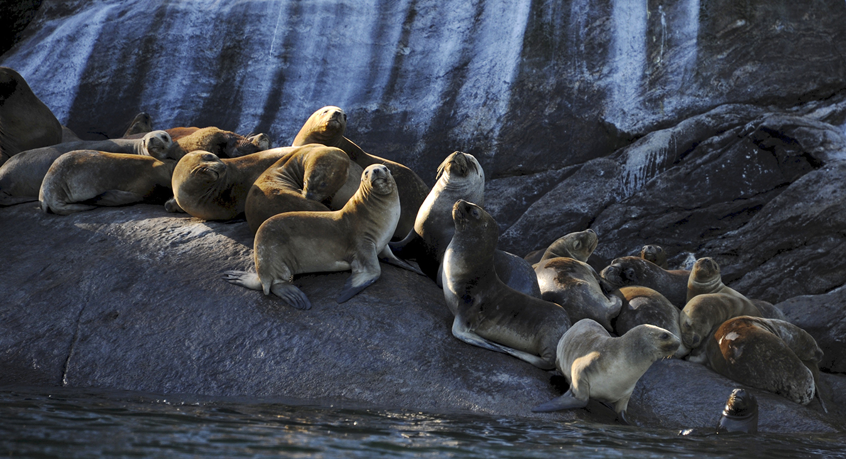
Day achievements : Very early wake up
How to manage your effort on a long day out.
Planning future and restoration of such an amazing place.

November 6th : Heading back.

Again, we’ll be on the water early and again we need to be organized to pack.
We paddle out back to the sea lions colony and this is where we will find Claudio, our support boat captain.

We load the kayaks on top of the fast boat and head back to Hornopiren. Mario our driver is waiting for us to help us pack the trailer , lunch in town and we head back to Ensenada for dinner and overnight under a roof and why not a hot shower….
B / L / D
Day achievements : following the logic of the trip and making our way back to civilization. In the evening we will be taking time to consider and share what we have learned during this expedition. Discussing on how such an experience impacts the future life of students

November 7th : Rafting

Different waters today… after breakfast we are at our base and will get to learn about new water crafts. We check our Aire rafts and understand the difference of river boating vs sea paddling. Our kit is slightly different and we have a morning spent on the river to learn about river hazards and features such as boilers, eddies, holes and V waves….
We will also take turns swimming rapids to make sure we will know what to do when we finish on the water and understand better the river.
Lunch will be on the river bank and we go on paddling in the afternoon on the easier lower stretch of the river.
We take advantage of gentle currents to learn how to drive the raft and to learn how to work as a team. Each student will be taking turns on the guide stick and will have to learn about sharing information and directions with his/her crew . These are amazing moments of leadership learning.
In the afternoon we are back at our B&B for dinner.
Day achievements : Learning , understanding and interacting with a different ecosystem. Working on leadership with fellow students under a certain level of stress as we need to steer the raft and at the same time that our crew is following instructions.
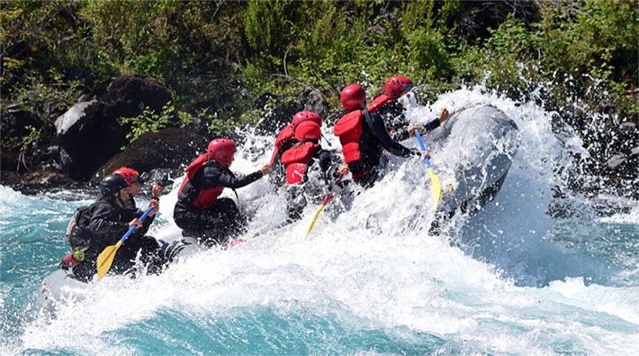

November 8th : Raft guiding

It is time today for the students to drive the raft in whitewater , sorting rapids safely with their crew and making sure they have the same amount of people in the raft at the end of the rapid than they had before it.
Early morning paddling
We also work on some safety specific drills and will be “playing” around with throw bags, 20 meters of rope in a bag to be thrown at swimmers.
We plan on doing 2 to 3 trips down the rio Petrohue for the students to learn their lines and the moves they need to ferry across the river and get through static waves (and stay in the raft meanwhile).
Day achievements : We will focus today on a bigger picture of the river world, the point is not to teach only how to steer a raft but to help the students understand the ecosystem. Not only telling what is bad and good but developing a critic point of view in front of projects that will impact river basins.
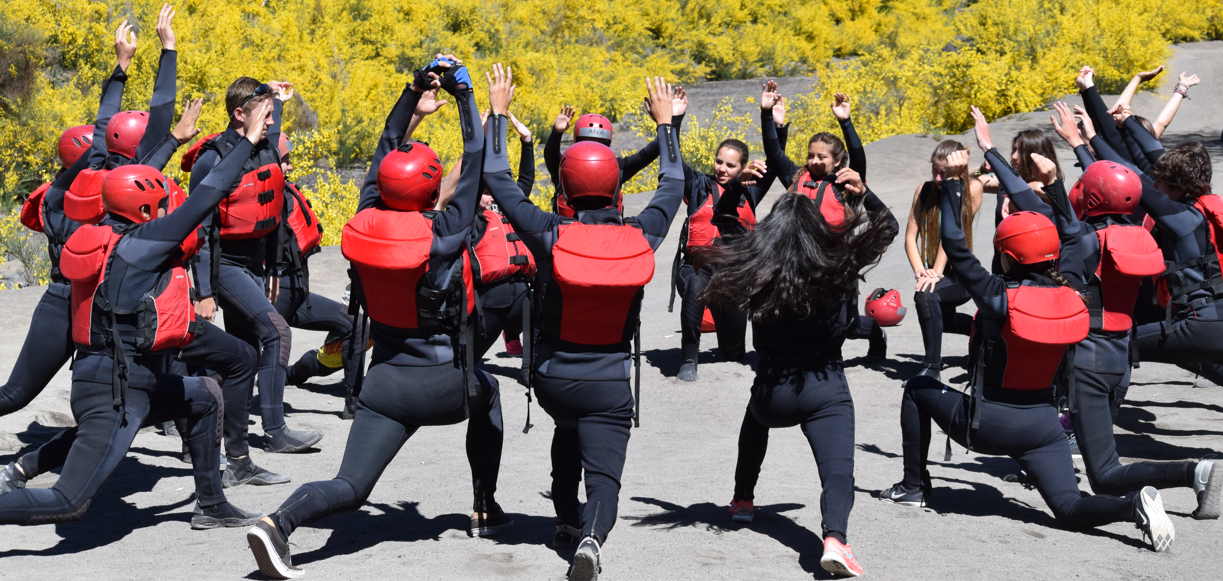

November 9th : Departure

Early personal debriefing with each student and transfer to Puerto Montt airport. B.

What’s included:
- The best Expedition kayaks available, single and tandem Kayaks: Necky Kayaks Looksha T. No boat is older than November 2017.
- Meals as described (B for breakfast – L for lunch box – D for dinner). Vegetarian and specific diets are available on demand.
- Nights in hotel and camping as described
- Private transportation during the whole trip.
- Bilingual guides.
- Complete technical gear (dry suits, kayak, paddles etc…)
- Safety / communication equipment.

What’s not included:
- Flights to and from Santiago
- Personal insurance
- All services NOT mentioned in the program.

Packing list:

 | Activity | What we provide | What to bring
 | Kayaking | Dry suits (in case of non availability in your size we provide wetsuits)  Homologated uscg pfds - Spray skirts - Dry bags  Radio & Sat communication | sneakers that can get wet  swim suit  neoprene or wool hat and wool or thermal buff  sun cap or hat  sun glasses – sun block  heavyweight thermal underwear (2 long sleeves and 1 bottom)  thermal socks to wear inside the dry suit  neoprene socks to wear outside the dry suit  lightweight thermal gloves  water bottle
Rafting |  | Neopren wet suit & jackets  USCG Homologated pfds ( 2017) and helmets  Comprehensive FA kit  13 and 14 foot rafts  Ropes, Carabiners, Pulleys etc…  Throw bags  Dry bags and cases  Communication  Photos/Video tools | Towel  Swimming suit  Thick Base layer (long johns, LS t shirts, cap) that will get wet  Wool, neoprene or fleece hat to go under the helmet  Neoprene socks  Good traction Sneakers that will get wet
Camping |  | Tents - Collective cooking and camping gear  Collective FA kit | sleeping bag  sleeping pad  head lamp  personal first aid  silverware
Meals / Lodging |  | - Hot and hearty Breakfast served at the cabins.  - Hot Lunches and dinners served at our Base’s restaurant.  - Overnights at cabins on the lake Llanquihue, cabins allow us to separate genders and have groups of up to 7 persons in each cabin.

What to pack:

On the water: | Camping: | At Camp:
- sneakers that can get wet  - swim suit  - neoprene or wool hat and wool or thermal buff  - sun cap or hat  - sun glasses – sun block  - heavyweight thermal underwear (2 long sleeves and 1 bottom)  - thermal socks to wear inside the dry suit  - neoprene socks to wear outside the dry suit  - lightweight thermal gloves  - water bottle | - sleeping bag  - sleeping pad  - head lamp  - personal first aid  - silverware | - low cut hiking shoes  - 1 hiking pants  - 1 rain pants  - 2 long leg thermal underwear  - 2 long sleeves thermal T Shirts  - 1 fleece/polar jacket  - 1 rain jacket  - warm wool or thermal beanie  - gloves – underwear – socks – t shirts  - towel

Each student will be paddling on his/her own so please keep that in mind when packing for your trip. Any comments or questions? Throw us a line at info@kokayak.cl

Instructors:
Michelle Blackwell:
- Born in Australia, 1974
- Has been guiding multi days sea kayaking and rafting trips in Australia, Nepal, Italy, Chile, USA, Canada, Peru, New Guinea among other countries.
- Member of Australia national women rafting team during 3 world championships.
- Wilderness Advanced First Aid certified
- Swift water rescue technician Level 3
- Nido’s week without walls lead instructor : Sea Kayak Pumalin November 2017.

Richard Carrier:
- Born in France, 1974.
- Has been guiding multiday sea kayaking and rafting trips in Italy, Chile, USA (Grand Canyon), France, Switzerland, and Austria.
- Wilderness Advanced First Aid certified
- Swift water rescue technician Level 3
- Nido’s week without walls lead instructor 2014/2015/2016/2017

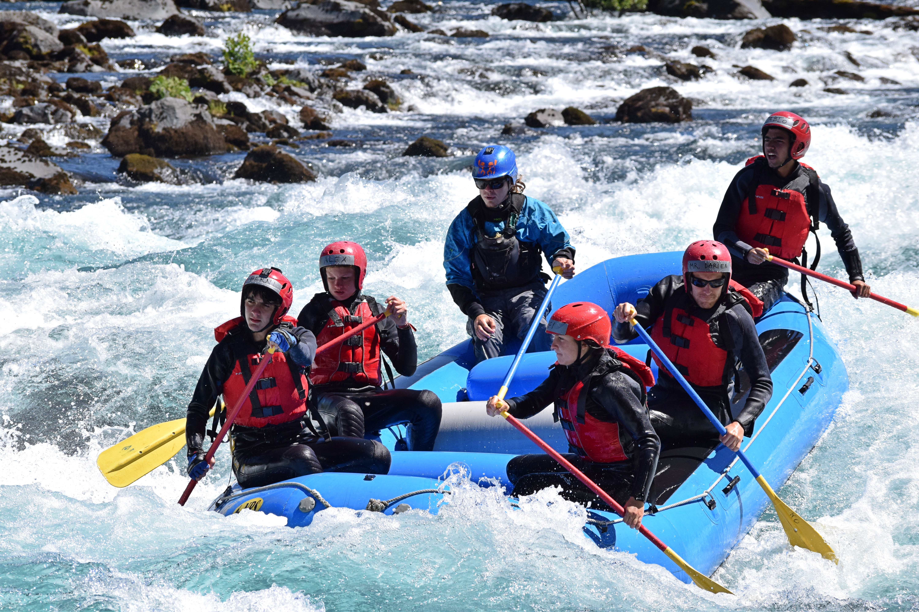
2016 Nido students

